***2021/04/17***

***Name: Bimal parajuli***

***Reg:20BDS0405***

***MATLAB FAT***

***Faculty Name: Dr. M. Prakash***

***Class Number: VL2020210505039***

***SLOT: L59 + L60***

***SET-D***

**ANSWERS IN NEXT PAGE**

1. **Obtain the maxima and minima value of f(x,y)=2(y2-x2)-y4+x4**

**CODES:**

clc

close all

clc

syms x y

f(x,y)=input('Enter function f(x,y) to calculate the maxima/minima');

p=diff(f,x); %df/dx

q=diff(f,y); %df/dy

[ax,ay]=solve(p,q);

ax=double(ax);

ay=double(ay);

r=diff(p,x); %d2f/dx2

s=diff(p,y); %d2f/dxdy

t=diff(q,y); %d2f/dy2

D=r*t-s^2;

figure

fsurf(f);

xlabel('X-axis');

ylabel('Y-axis');

zlabel('Z-axis');

legstr={'Plot of the given function'};

for i=1:size(ax)

t1=D(ax(i),ay(i));

t2=r(ax(i),ay(i));

t3=f(ax(i),ay(i));

if (double(t1)==0)

sprintf('At (%f,%f) further investigation needed',ax(i),ay(i))

legstr=[legstr,{'Case to investigate further'}];

mkr='ko';

elseif (double(t1)<0)

sprintf('The point(%f,%f) is a saddle point',ax(i),ay(i))

legstr=[legstr,{'Saddle point'}];

mkr='bv';

else

if (double(t2)<0)

sprintf('The maximum value is %f at the point(%f,%f)',t3,ax(i),ay(i))

legstr=[legstr,{'maximum value of function'}];

mkr='g+';

else

sprintf('The minimum value is %f at the point(%f,%f)',t3,ax(i),ay(i))

legstr=[legstr,{'minimum value of the function'}];

mkr='r+';

end

end

hold on;

plot3(ax(i),ay(i),t3,mkr,'linewidth',3);

end

legend(legstr,'location','best');

title('Plot of f(x,y) showing maxima/minima')

**INPUT:**

Enter function f(x,y) to calculate the maxima/minima

2*(y^2-x^2)-y^4+x^4

**OUTPUT:**

ans =  
  
 'The point(0.000000,0.000000) is a saddle point'  
  
  
ans =  
  
 'The minimum value is -1.000000 at the point(-1.000000,0.000000)'  
  
  
ans =  
  
 'The minimum value is -1.000000 at the point(1.000000,0.000000)'

ans =  
  
 'The maximum value is 1.000000 at the point(0.000000,-1.000000)'  
  
  
ans =  
  
 'The maximum value is 1.000000 at the point(0.000000,1.000000)'  
  
  
ans =  
  
 'The point(-1.000000,-1.000000) is a saddle point'  
  
  
ans =  
  
 'The point(1.000000,-1.000000) is a saddle point'  
  
  
ans =

**RESULTS:**

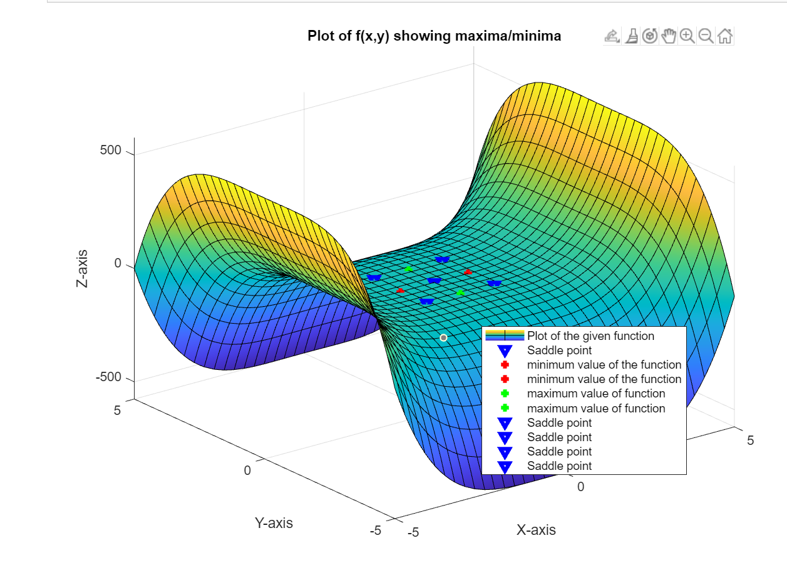

1. **Find the volume of the region enclosed by z= x2+3y2 and z=6-x2-y2. Use ‘input’ and add title, legend, axis to the graph.**

**CODE:**

clear

close all

clc

syms x y z;

f=input('Enter the function');

%assigning the lomit for integration along x,y,z

za=x^2+3*y^2;

zb=6-x^2-y^2;

ya=-sqrt((3-x^2)/2);

yb=sqrt((3-x^2)/2);

xa=-sqrt(3);

xb=sqrt(3);

%calculating and displaying the total volume of integration

volume=int(int(int(f,z,za,zb),y,ya,yb),x,xa,xb);

disp("the volume enclosed is")

disp(volume)

%visualizing the 3D plot

viewSolid(z,za,zb,y,ya,yb,x,xa,xb);

grid on;

hold on;

xlabel('x-axis')

ylabel('y-axis')

zlabel('z-axis');

%giving title to the 3D plot

title('Volume enclosed in the solid')

hold off;

**INPUT:**

Enter the function

1+0*x

**OUTPUT:**

the volume enclosed is  
(9*pi*2^(1/2))/2

